**Assignment 02 – Twitter Service**

Develop a simple twitter service that implement any Twitter API to programmatically create, retrieve and delete a Tweet in the Twitter Sandbox environment. e.g., ads-api-sandbox.twitter.com .

https://developer.twitter.com/en/docs/ads/general/overview/ads-api-sandbox.html (Links to an external site.)

Develop a simple Web UI that implements your service and demonstrates the functions.

The twitter documentation is here:

<https://developer.twitter.com/en/docs/ads/general/guides/getting-started> (Links to an external site.)

<https://developer.twitter.com/en/docs/developer-utilities/twitter-libraries> (Links to an external site.)

Also. the example code in the Twitter Websocket Blueprint Example may be helpful.

See here:

<https://github.com/apache/camel-examples/tree/master/examples/camel-example-twitter-websocket>

**NOTES**:

* Include in the source code comments, i.e. who wrote which code.
* Code should include Unit tests (e.g. jUnit, TestNG, unittest, etc..)
* Submit a Word Document of UI interaction, with screenshots
* Good Coding.

**Source Code for assignment is at Git Hub repo:-**

<https://github.com/poojashreeNS/Assignments/tree/main/HW%232_Twitter_Service>

**Unit tests** are run by test.py and results are captured in below screenshots, uploaded in GitHub:

1. Unit_test_Case_with_error_capturing.png
2. Unit_test_case_success.png

**Team Members: -**

1. Avinash Ramesh
2. Charu Cheema
3. Nisha Devadiga
4. Poojashree NS

A simple web-based UI – “**Twitter Tweets**” has been developed to Post , Retrieve and Delete the tweet from Twitter.

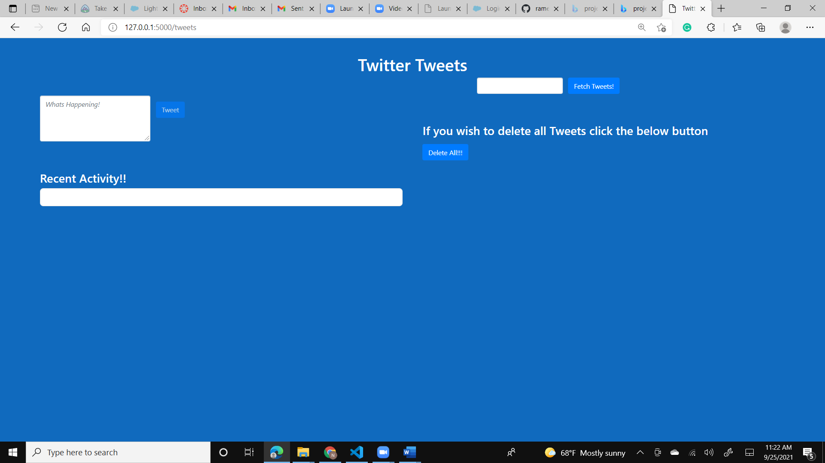

1. **Post Status on Twitter :-**

User types status in the given textarea to post the tweet on the Twitter.

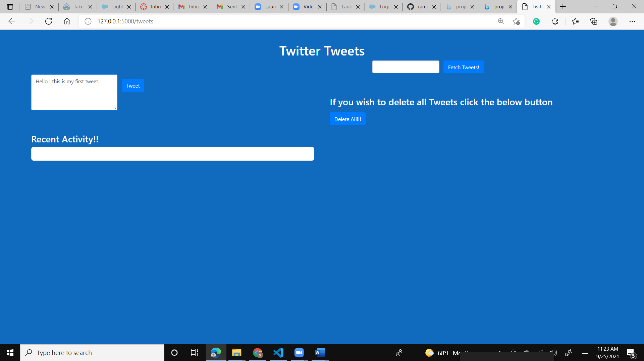

The tweet “Hello ! this is my first tweet.” is posted on Twitter and, under *Recent Activity!! o*n the webpage.

**Web UI:**

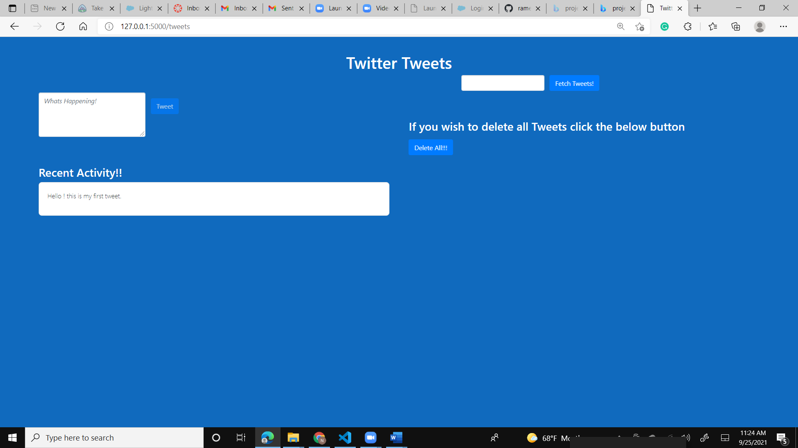**Twitter:**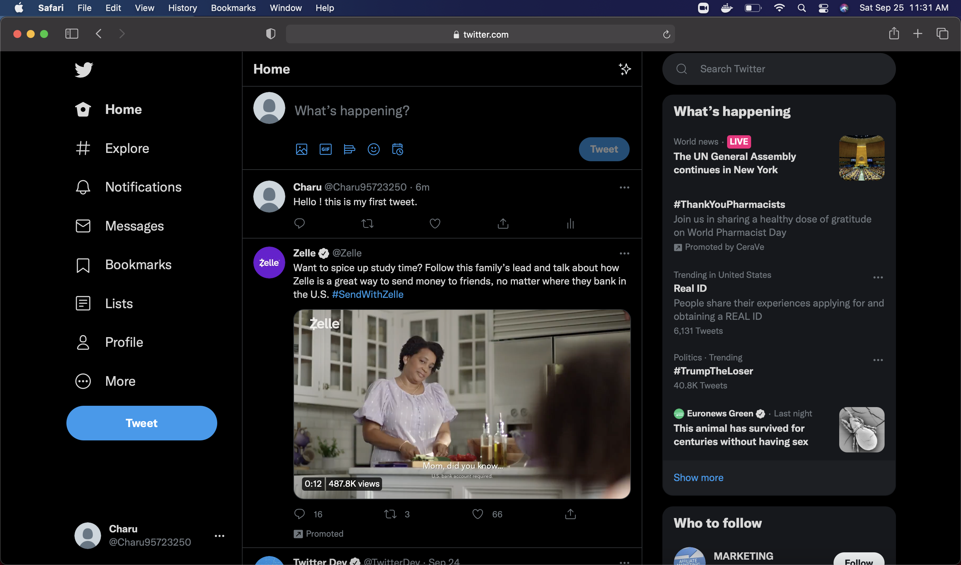

User can type multiple statuses, one at a time, and the “Recent Activity!!” section in the webpage as well as the Twitter page will be updated accordingly.

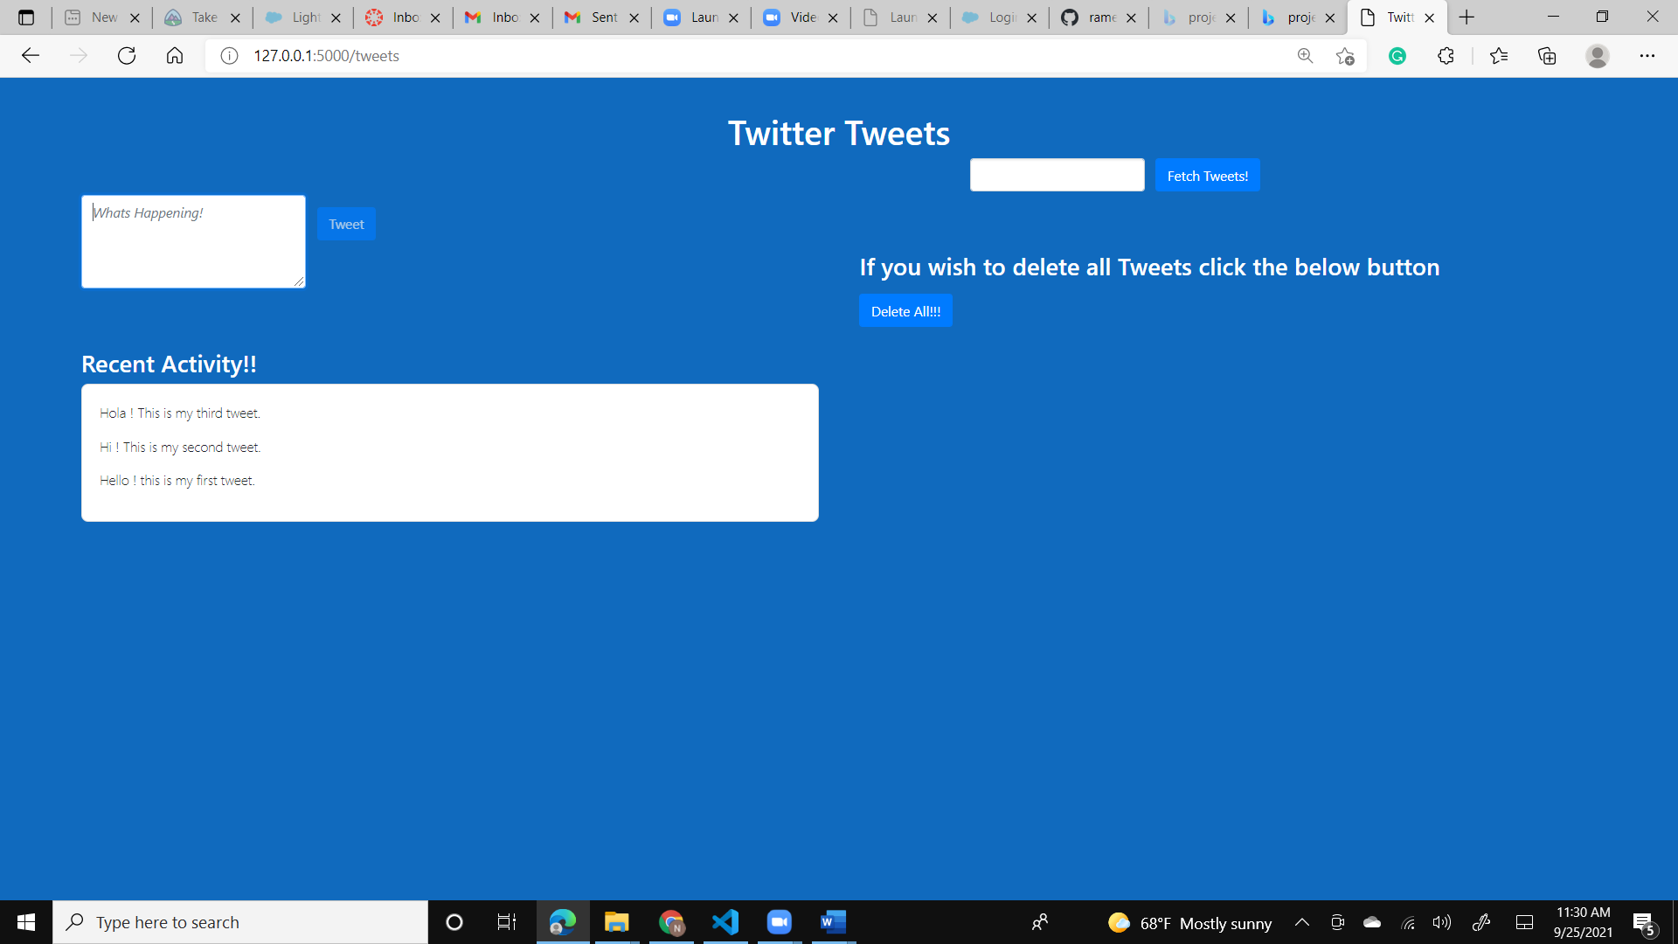**Twitter:**

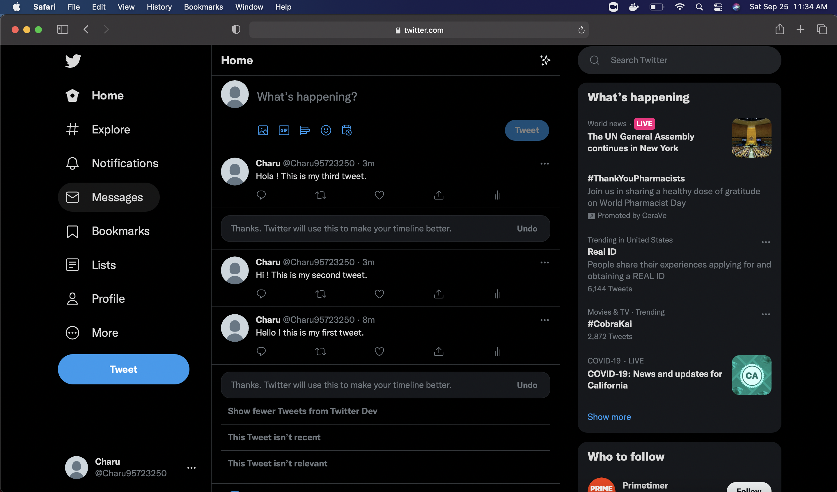

1. **Retrieve status in Twitter :-**

User enters beginning keyword of the posted tweet to retrieve it from Twitter and displays it on the screen. For example, to fetch the tweet with keyword “Hola”.

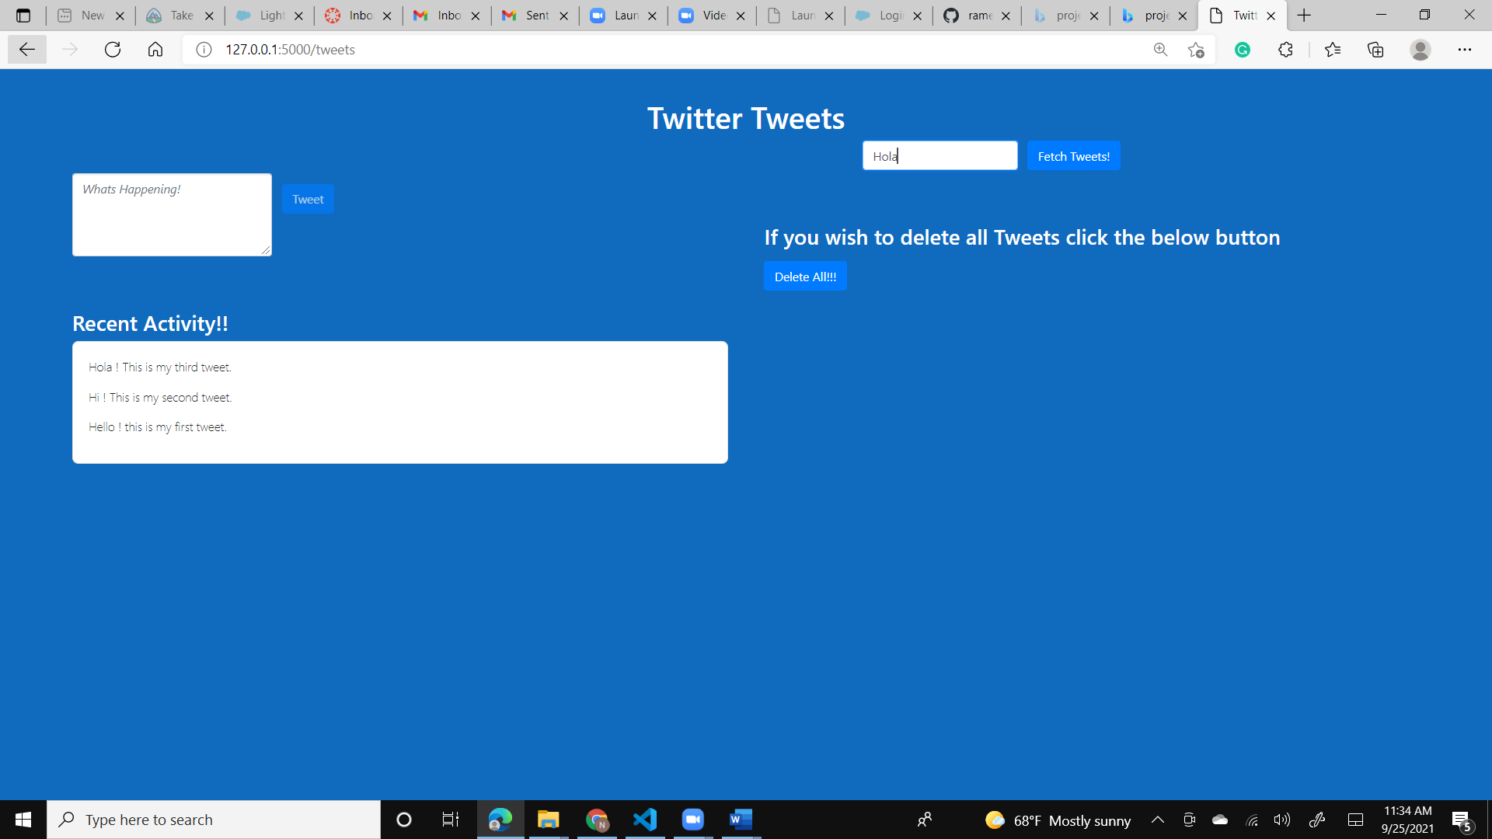

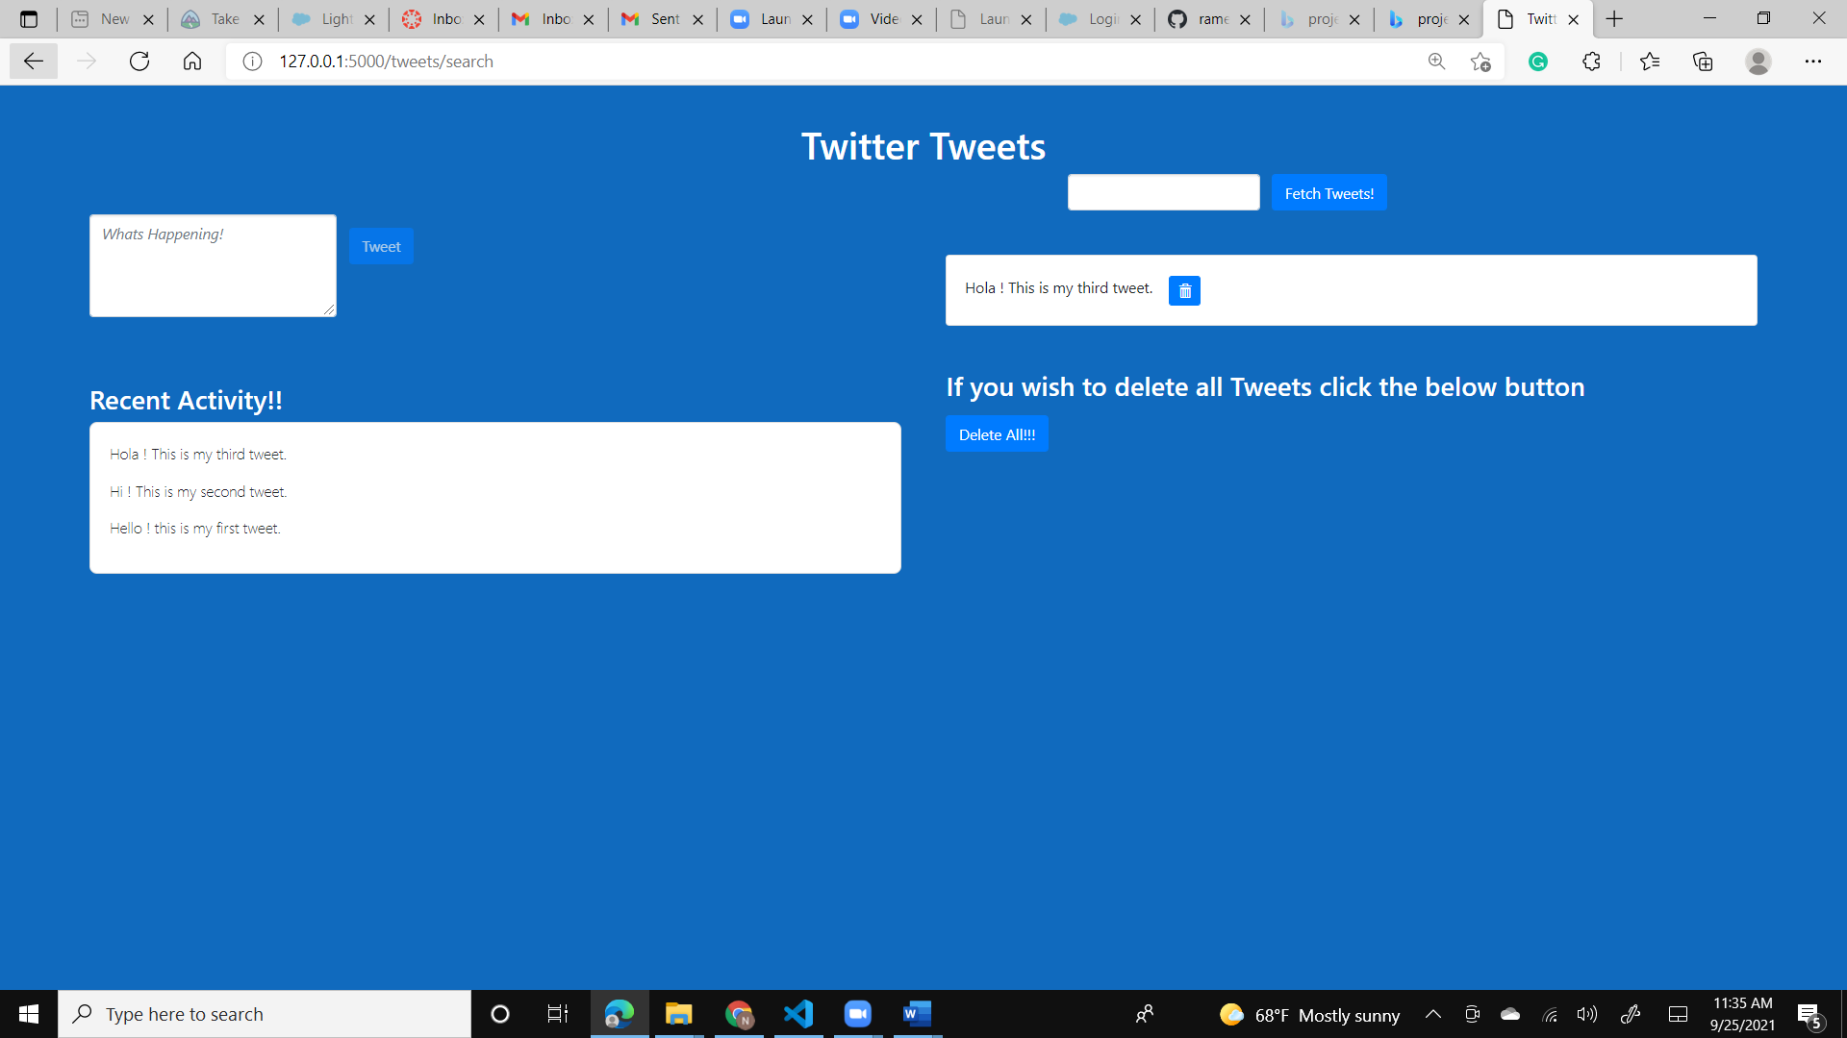

Multiple tweets with beginning keyword “Hello ” can also be fetched as shown below:-

**Twitter:**

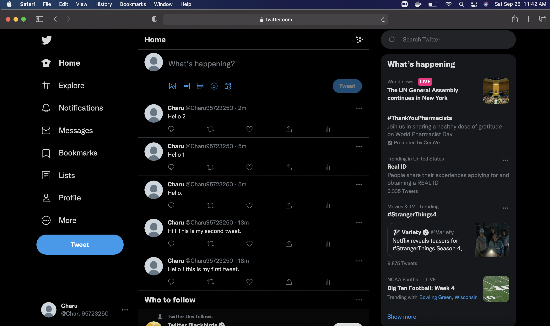

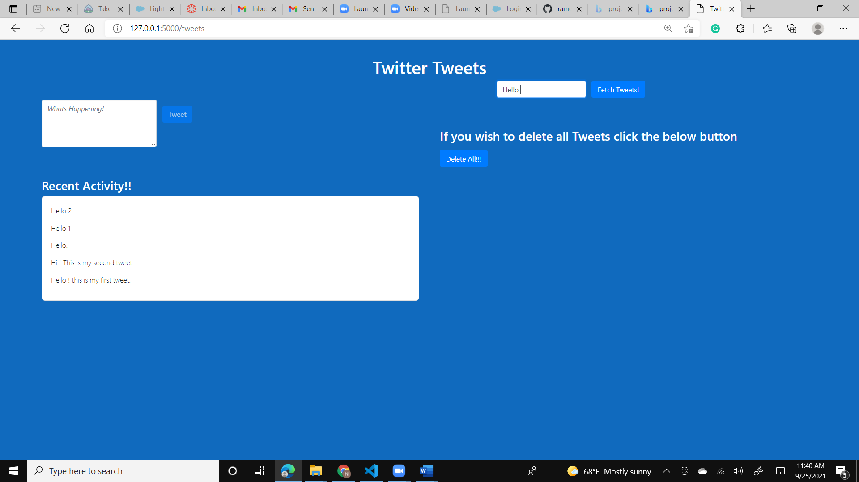

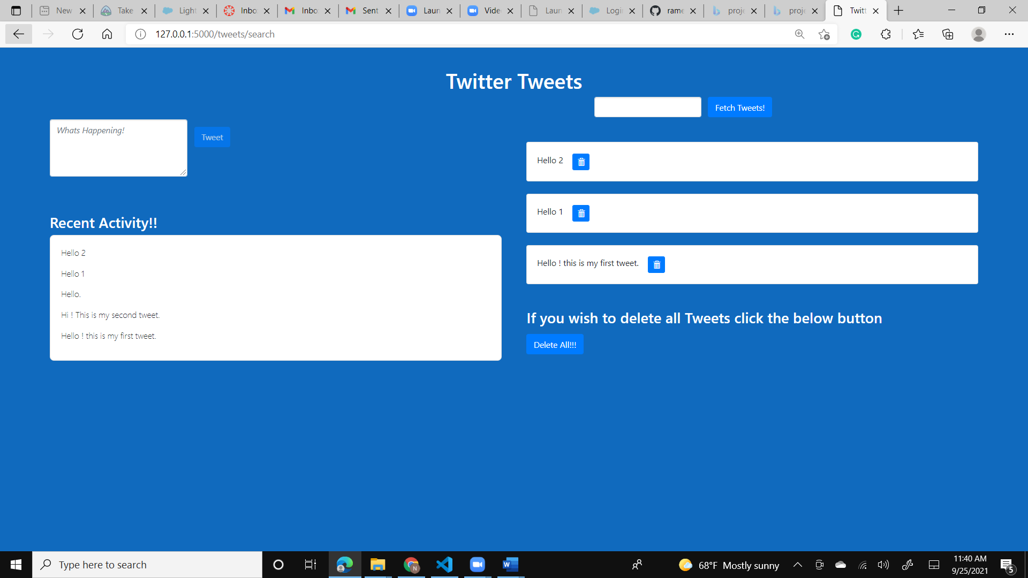

1. **Delete status on Twitter :-**

User clicks on Delete icon  next to retrieved tweet to delete it. As seen below, tweet – “Hola ! This is my third tweet.” is already fetched for deletion. Clicking on delete icon deletes that tweet under the “Recent Activity!!” section in the webpage as well as on the Twitter page.



**Web UI:**

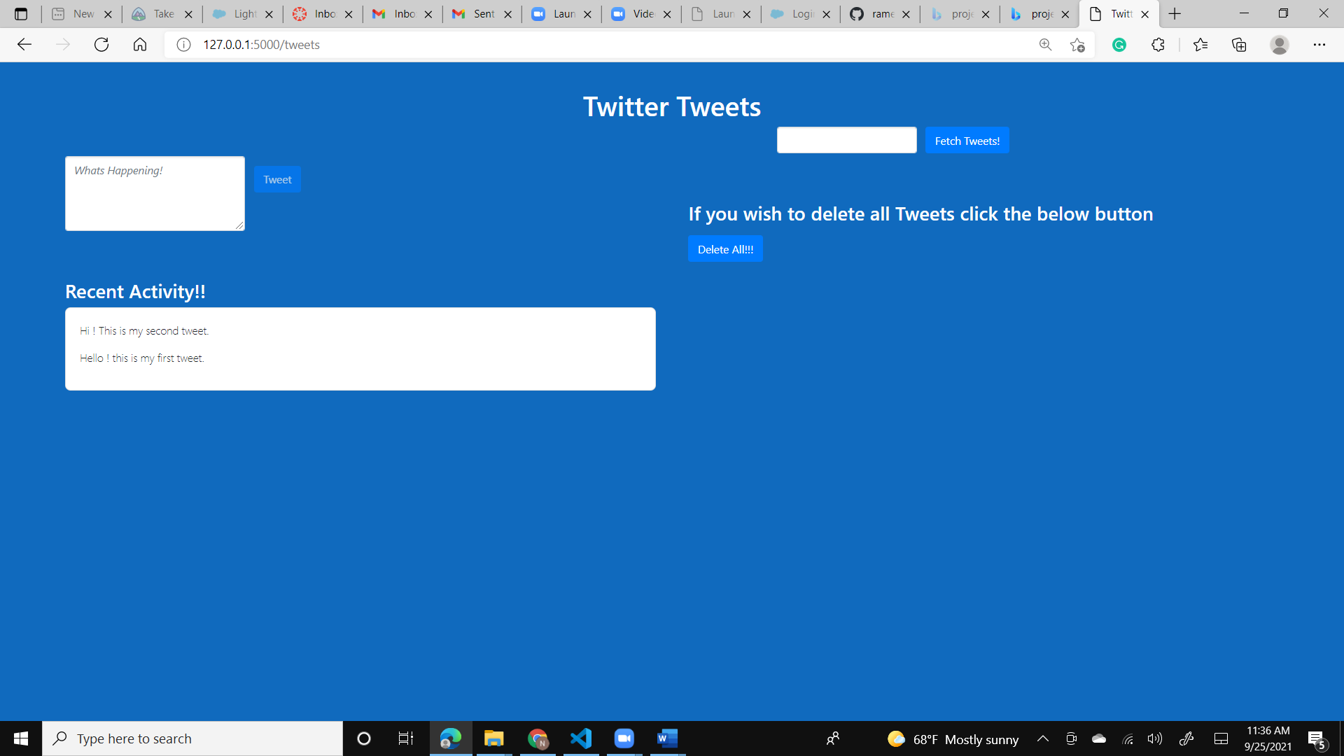

**Twitter:**

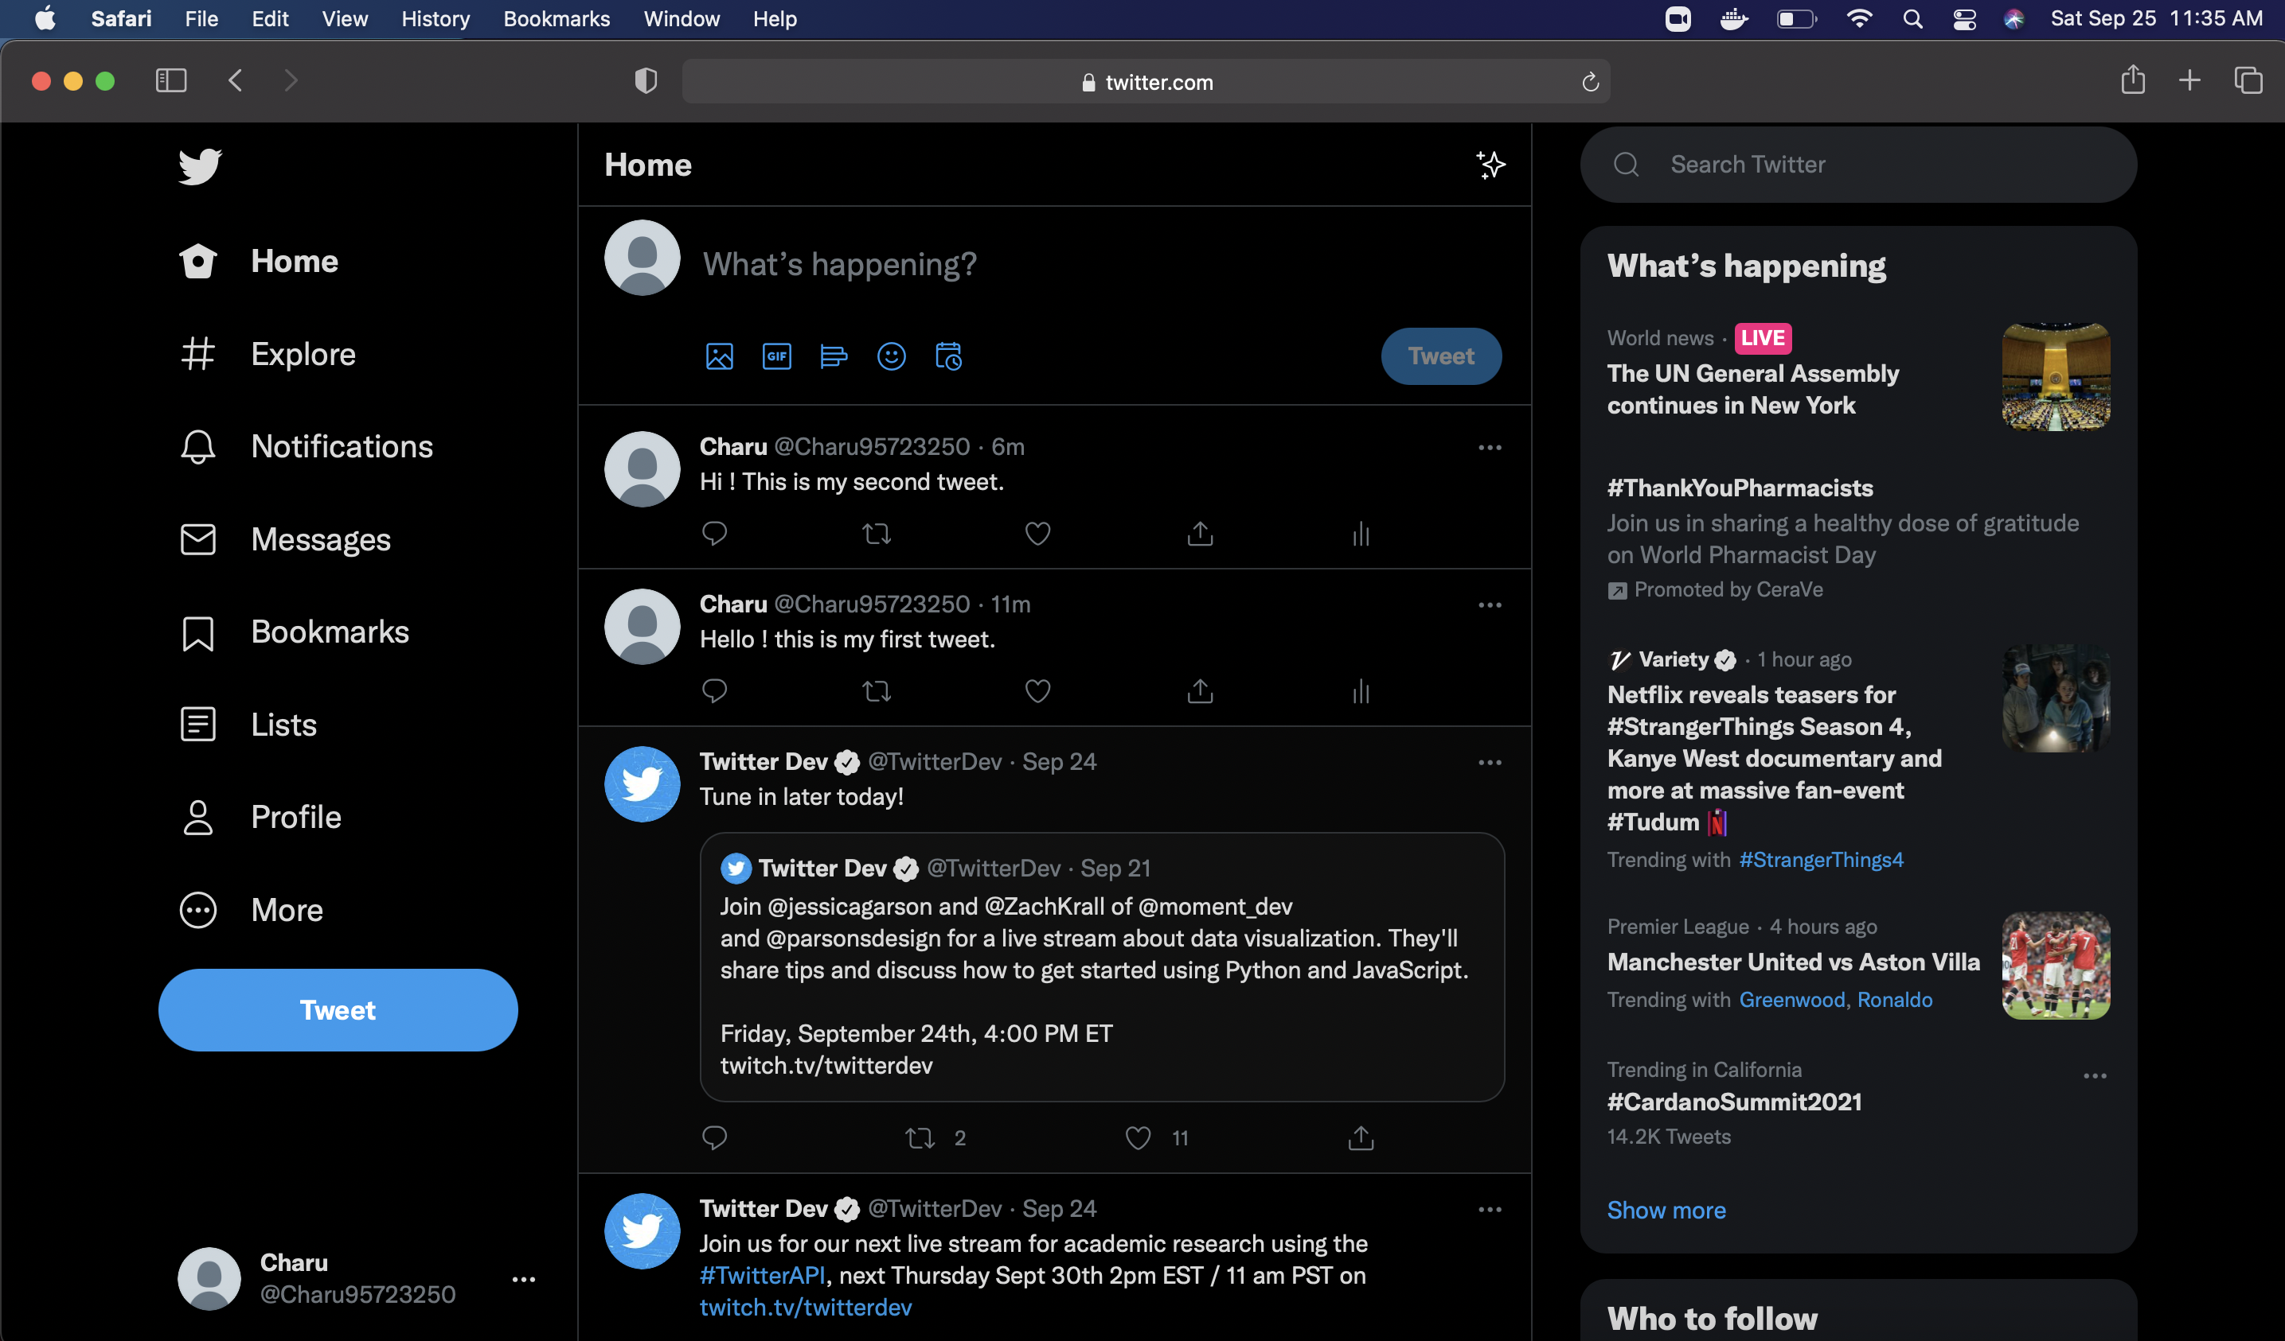

To Delete all tweets posted till now ,the user clicks on “Delete All” button on the webpage.

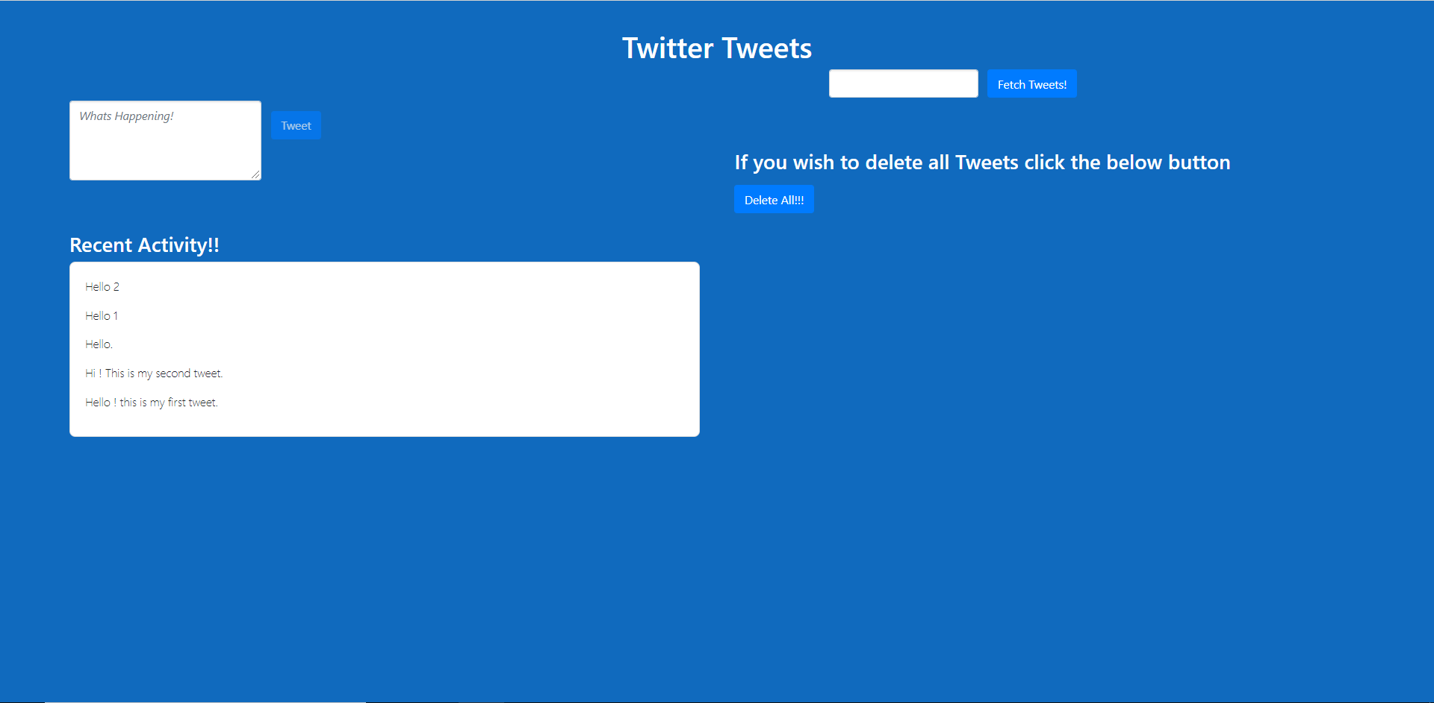

As seen below, the “Recent Activity!!” section indicates all tweets are deleted:-

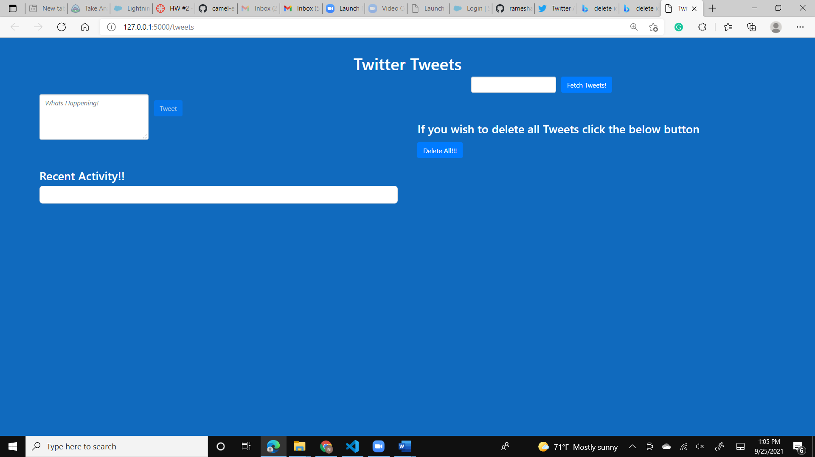

The same is reflected on Twitter as well:-

**Twitter:**

